Running Python Locally

**How to Run a Python Script**

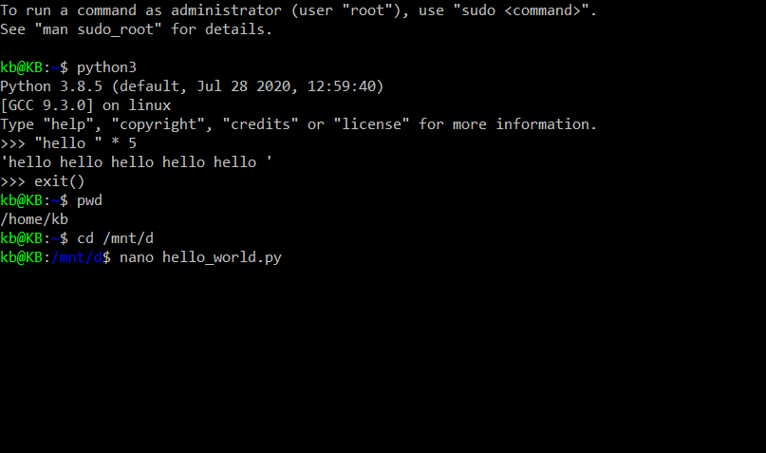

1. Use Cygwin64 as Linux emulator for Windows or download Ubuntu as part of Windows Subsystem for Linux from Microsoft Store. For my notes I will be using Ubuntu WSL Terminal.

2. hello_world.py needs to be created first (as the instructor didn’t show us). So we can use text editor to create a text file and modify the extension to **.py**.

3. For my case, I placed the hello_world.py in one of the folders in D Drive. And then change its directory to where the file located at: cd /mnt/d/iCloud\ Drive/Online\ Courses/Coursera/Google\ IT\ Automation\ with\ Python\ Professional\ Certificate

*\* Note: If there are spaces in the filename, use backslash (\) or quotes.*

4. We can add the extra line to our file called shebang, which tells the operating system what command we want to use to execute that script. Let's try this now. First, open the file on editor. For this example, we're going to use **nano**, which is one of the editors available on a Linux system.

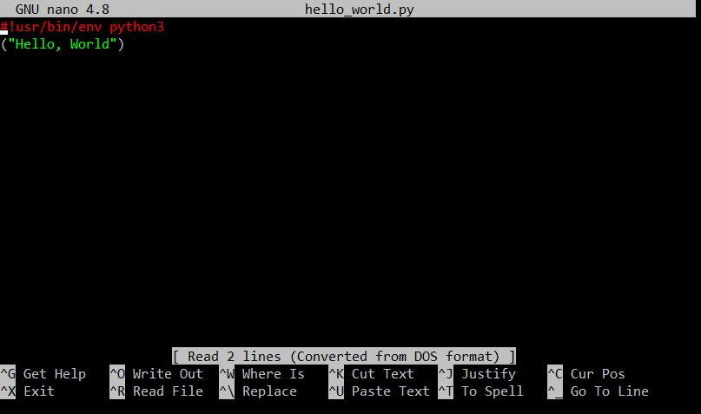

5. Use **nano hello_world.py** to open this. Now, we'll add our magic line at the beginning of the file. This line tells the OS that we want to run the script using Python 3. Adding the shebang and it looks like this: “**#!/usr/bin/env python3**”. We can now exit nano by pressing **Ctrl+O > Enter > Ctrl+X**, and saying that we want to save the file, and then accepting the proposed name which is the same name that the file had before.

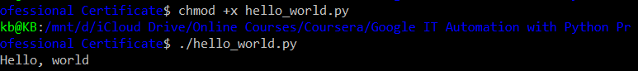

6. And now our system knows it should execute the file with a Python 3 interpreter. There's one more thing we need to do to run the script directly without having to call the interpreter every time. We need to make that file executable using the **chmod** command. Remember that this command let’s change the file permissions. A file's possible permissions are read, write, and execute. To run the file directly, we want our file to be executable. This is how we do it: “**chmod +x hello_world.py**”. Marking the script as executable means that we can now run the file by just prefixing it with a “**./**”.